Progress Report – PCI system

Rakshit Singh – FCS113

Avnit Sharma – FCS041

Project Description

The software to be designed is an open source online Personal Counseling Interaction system for an institute that will be deployed on the web, so as to ease/speedup the admission process (PCI). This software will create a video communication channel through which the faculty (interviewer) will be able to assess the student/applicant (interviewee) and shortlist him for admission to the institute.

Goals

The software/system should have the following features/properties:

* Developed for the web (internet), i.e. a Web App.
* Be cross compatible i.e. compatible across multiple browsers.
* Be open source.
* Have a GUI (graphical user interface) that is user friendly.
* Connection to the client (applicant) should be via a hyper-link that the server (interviewer) provides.
* Must be safe and secure.
* Options for one to one and group conference.
* Questionnaires fill up option.
* Document Sharing mechanism.
* Chat Box.

Current Scenario

* Selected WebRTC as the platform.
* Selected GoogleDrive for data storage.
* Selected Google Forms for questionnaire.
* Started testing the above mentioned.

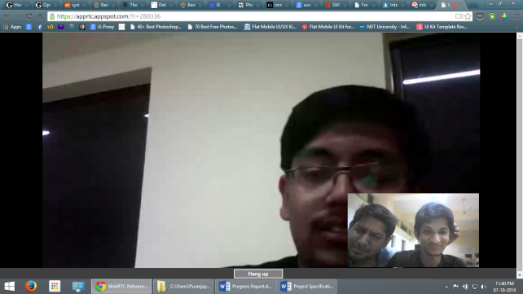

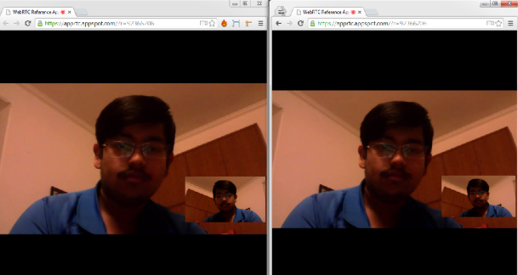 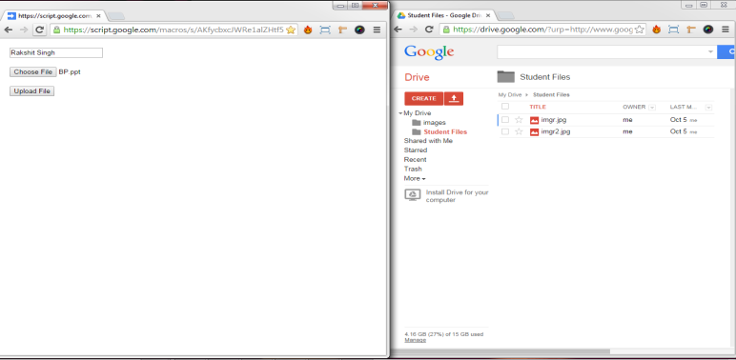

Timeline

Phase 1

Requirements – Gathered requirements from customer.

Research – Looked for best available technologies and platforms to support our cause. Finally, narrowed down to WebRTC and GoogleDrive.

Design-Crude Prototyping – Basic video conferencing app and basic file uploading to google drive mechanism.

Phase 2

Implementing phase – Coding and designing the functionalities, modules and developing the GUI.

Finalizing the requirements phase i.e. the prototyping and moving towards stability, testing and maintainability of the project.

Phase 3

Testing phase – Testing the project for all bugs and errors.

Hosting project on github and providing 3rd party support.

Phase 4

Finally publishing the project and hopefully getting a good grade.

Maintaining the project via github.